Subject: Evaluation of 5G Open RAN simulation environments
RAN= Radio access Networks
BBU=Based -band Units
RRU= Remote Radio Units
Rus= Remote units
DUs= Distributed units
CUs= Centralized units

RAN= A Radio Access Network (RAN) is the part of a telecommunications system that connects individual devices to other parts of a network through radio connections. A RAN resides between user equipment, such as a mobile phone, a computer or any remotely controlled machine, and provides the connection with its core network. The RAN is a major component of wireless telecommunications and has evolved through the generations of mobile networking leading up to 5G.

The O-RAN architecture
https://www.stl.tech/blog/understanding-o-ran-from-the-basics/
The O-RAN architecture is well documented in the O-RAN alliance. The key elements of the O-RAN architecture are:

Service Management and Orchestration Framework (SMO)—includes an integration fabric and data services for the functions it manages. It allows managed functions to interoperate and communicate within the O-RAN. The SMO connects to and manages the RICs, O-Cloud, the O-CU, and O-DU.
RAN Intelligent Controller (RIC) – There are two types of RICs – non-real-time and near-real-time. Both are logical functions for controlling and optimizing the elements and resources of an O-RAN. A near-real-time RIC controls and optimizes elements and resources with granular data collection and communication over the E2 interface. The E2 interface connects the near-real-time RIC with the O-CU and O-DU.
O-Cloud is a cloud computing platform made up of the physical infrastructure nodes using the O-RAN architecture. It also creates and hosts the various virtual network functions (VNFs) used by the RICs and other infrastructure elements.
O-RAN central unit (O-CU) – Logical node that hosts a handful of protocols, which are the radio resource control (RRC), service data adaptation protocol (SDAP), and packet data convergence protocol (PDCP).
O-RAN distributed unit (O-DU) is a logical node that hosts another set of protocols, which are the radio link control (RLC) protocol, medium access control (MAC) protocol, and the physical interface (PHY).
O-RAN Radio unit (O-RU) – It processes radio frequencies received by the physical layer of the network. The processed radio frequencies are sent to the O-DU through a front haul interface.
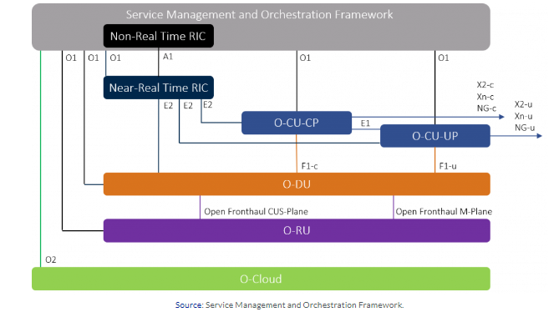
Key Components of O-RAN (Open RAN)
The primary components of O-RAN are:

Cloudification: The O-RAN architecture involves hardware and software disaggregation and using RAN applications as cloud-native functions. The 5G RAN has three primary building blocks:

The Radio Unit
The Distributed Unit
The Centralized Unit
Intelligence and automation: ORAN technology uses open management and orchestration with external AI/ML capabilities. Additionally, it has RAN automation interfaces.

Open internal RAN interfaces: 5G ORAN technology includes interfaces defined by 3GPP and the ORAN Alliance. The interfaces are as follows:

Higher Layers Split
Inter-node Communication
O-RAN lower layer split
Near-Real-Time RIC

O-RAN implementation
ORAN indeed creates new opportunities in radio access network technology. However, operators must consider network security before implementing ORAN technology. It is necessary to have a secure microservices-based architecture for a safe, modern, cloud-native implementation of ORAN.

The O RAN Alliance provides functional compliance to the specifications of components. But for implementation, stakeholders require verification, integration, interoperability, and testing of the commoditized 5G RAN elements. These are necessary to support a plug-n-play model. Therefore, besides commoditization of services, you also need an efficient orchestration of the different ORAN 5G components. Only then can you guarantee stable networks.

The implementation of ORAN technology may increase security risks. First, the API exposure increases because an Open Radio Access Network can have different vendor apps. And each app will expose the APIs. Further, the network will be heterogeneous: apps will be on various network types. So we can’t consider any network to be safe while implementing.
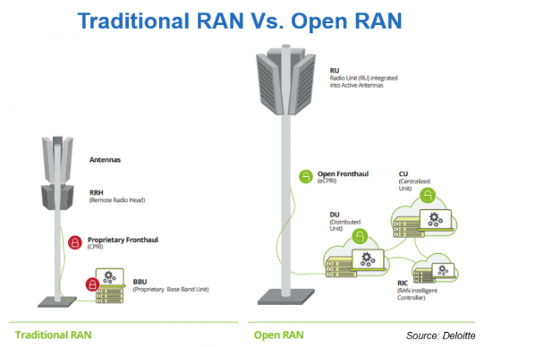

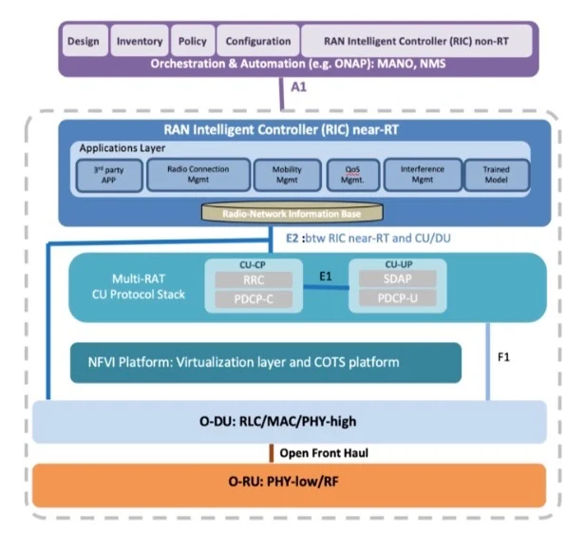

The first is its open interface, which the O-RAN Alliance’s whitepaper says will allow smaller vendors to introduce their own services and allow operators to customize the network as needed. It will also allow multiple vendors to deploy their technology on the network, thereby enabling competition and reducing costs.
The second core principle of O-RAN is intelligence. The deployment of 5G and the applications that come along with it will increase network complexity to the point that it is no longer viable for humans to operate and optimize the network. The network must be able to operate on its own and learn as it goes along, which is why the O-RAN Alliance calls for embedded intelligence at all levels of the network.

